**What is Cloud Computing?**

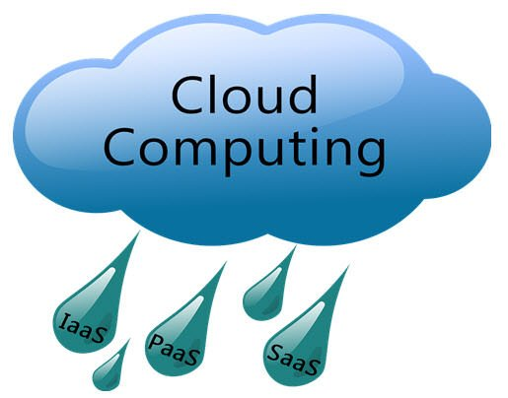

**Cloud Computing** is defined as storing and accessing of data and computing services over the internet. It doesn’t store any data on your personal computer. It is the on-demand availability of computer services like servers, data storage, networking, databases, etc. The main purpose of cloud computing is to give access to data centers to many users. Users can also access data from a remote server.

Storing your information on OneDrive, SharePoint, or an email server is much different from keeping that data on a desktop hard drive or a USB stick. You can access it from just about any computer that has internet access.

A cloud can be private or public. A public cloud sells services to anyone on the internet. A private cloud is a proprietary network or a data centre that supplies hosted services to a limited number of people, with certain access and permissions settings. Private or public, the goal of cloud computing is to provide easy, scalable access to computing resources and IT services.

**Why the Name Cloud?**

The term “Cloud” came from a network design that was used by network engineers to represent the location of various network devices and their inter-connection. The shape of this network design was like a cloud.

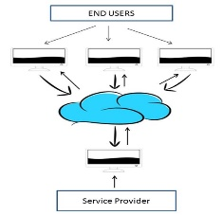

**Why Cloud Computing?**

With increase in computer and Mobile user’s, data storage has become a priority in all fields. Large and small scale businesses today thrive on their data & they spent a huge amount of money to maintain this data. It requires a strong IT support and a storage hub. Not all businesses can afford high cost of in-house IT infrastructure and back up support services. For them Cloud Computing is a cheaper solution. Perhaps its efficiency in storing data, computation and less maintenance cost has succeeded to attract even bigger businesses as well.

Cloud computing decreases the hardware and software demand from the user’s side. The only thing that user must be able to run is the cloud computing systems interface software, which can be as simple as Web browser, and the Cloud network takes care of the rest. We all have experienced cloud computing at some instant of time, some of the popular cloud services we have used or we are still using are mail services like Gmail, Hotmail or yahoo etc.

While accessing e-mail service our data is stored on cloud server and not on our computer. The technology and infrastructure behind the cloud is invisible. It is less important whether cloud services are based on HTTP, XML, Ruby, PHP or other specific technologies as far as it is user friendly and functional. An individual user can connect to cloud system from his/her own devices like desktop, laptop or mobile.

**Benefits of Cloud Computing**

The potential for cost saving is the major reason of cloud services adoption by many organizations. Cloud computing gives the freedom to use services as per the requirement and pay only for what you use. Due to cloud computing it has become possible to run IT operations as an outsourced unit without much in-house resources.

1. Lower IT infrastructure and computer costs for users
2. Improved performance
3. Fewer Maintenance issues
4. Instant software updates
5. Improved compatibility between Operating systems
6. Backup and recovery
7. Performance and Scalability
8. Increased storage capacity
9. Increase data safety

**Cloud computing service providers**

* AWS
* GCP
* Microsoft Azure
* Apple
* Citrix
* IBM
* Salesforce
* Alibaba
* Oracle
* VMware
* SAP
* Joyent
* Rackspace

**Cloud Services**

* Email
* Storage, backup, and data retrieval
* Creating and testing apps
* Analysing data
* Audio and video streaming
* Delivering software on demand

**AWS Cloud**

Amazon Web Services (AWS) is the world’s most comprehensive and broadly adopted cloud platform, offering over 200 fully featured services from data centers globally. Millions of customers—including the fastest-growing start-ups, largest enterprises, and leading government agencies—are using AWS to lower costs, become more agile, and innovate faster.

**What Is Amazon Web Services?**

Amazon Web Services or AWS as an abbreviation is a popular Cloud Service Provider that enables on-demand services like compute, storage, networking, security, databases, etc. which can be accessed through the internet across the globe and the user is not required to manage or monitor these resources.

Amazon Web Services is a global leader in terms of Public Cloud market share and provides cloud solutions in 245 different countries across the globe. It provides more than 200 Cloud Computing services, which touch domains like,

* Storage
* Computation
* Security
* Databases
* Networking
* Monitoring
* Migration
* Messaging
* Analytics
* DevOps
* IoT
* Big Data, etc.

Amazon Web Services (AWS) is a versatile, secure and reliable cloud service provider and is the most sort after Cloud Computing and Hard skill in the market. Companies have invested billions of dollars in this service provider and the number shows an upward trend in the near future. The major reason why sees this the market reach of Amazon Web Services, the quality of services and support it provides and the benefits it offers.

**AWS is the leading cloud platform**

1. **Most functionality**

AWS has significantly more services, and more features within those services, than any other cloud provider–from infrastructure technologies like compute, storage, and databases–to emerging technologies, such as machine learning and artificial intelligence, data lakes and analytics, and Internet of Things. This makes it faster, easier, and more cost effective to move your existing applications to the cloud and build nearly anything you can imagine.

AWS also has the deepest functionality within those services. For example, AWS offers the widest variety of databases that are purpose-built for different types of applications so you can choose the right tool for the job to get the best cost and performance.

1. **Largest community of customers and partners**

AWS has the largest and most dynamic community, with millions of active customers and tens of thousands of partners globally. Customers across virtually every industry and of every size, including start-ups, enterprises, and public sector organizations, are running every imaginable use case on AWS. The AWS Partner Network (APN) includes thousands of systems integrators who specialize in AWS services and tens of thousands of independent software vendors (ISVs) who adapt their technology to work on AWS.

1. **Most secure**

AWS is architected to be the most flexible and secure cloud computing environment available today. Our core infrastructure is built to satisfy the security requirements for the military, global banks, and other high-sensitivity organizations. This is backed by a deep set of cloud security tools, with 230 securities, compliance, and governance services and features. AWS supports 90 security standards and compliance certifications, and all 117 AWS services that store customer data offer the ability to encrypt that data.

1. **Fastest pace of innovation**

With AWS, you can leverage the latest technologies to experiment and innovate more quickly. We are continually accelerating our pace of innovation to invent entirely new technologies you can use to transform your business. For example, in 2014, AWS pioneered the server less computing space with the launch of AWS Lambda, which lets developers run their code without provisioning or managing servers. And AWS built Amazon SageMaker, a fully managed machine learning service that empowers everyday developers and scientists to use machine learning–without any previous experience.

1. **Most proven operational expertise**

AWS has unmatched experience, maturity, reliability, security, and performance that you can depend upon for your most important applications. For over 15 years, AWS has been delivering cloud services to millions of customers around the world running a wide variety of use cases. AWS has the most operational experience, at greater scale, of any cloud provider.

**Global network of AWS Regions**

AWS has the most extensive global cloud infrastructure. No other cloud provider offers as many Regions with multiple Availability Zones connected by low latency, high throughput, and highly redundant networking. AWS has 84 Availability Zones within 26 geographic regions around the world, and has announced plans for 24 more Availability Zones and 8.

**Benefits of Amazon Web Services**

Amazon Web Services(AWS) offers numerous benefits, let us explore a few of these ones by one:

1. **AWS Pricing**

Whether you are a small scale start up or a full-fledged enterprise, Amazon Web Services has you covered when it comes to pricing. Firstly, it offers ‘pay as you go model’, that means you pay for resources in volumes and duration you use them for. It charges you on a per-minute basis. Meaning if a resource is used for 30 minutes you be charged only for those 30 minutes and not more. It also offers a calculator that lets you track your expenses.

1. **Zero Commitment**

Whether you need to host a website, or even a high traffic hosting content delivery network. Amazon Web Services keeps you covered. You spawn a virtual machine, a database service or a data warehouse. This happens with you not requiring to be in an upfront commitment. This is because Amazon Web Services charges you on per minute and for some resources per hour basis. This means you are not tied with any yearly, quarterly or even monthly commitments.

1. **Scalability and Procurement**

If your applications lie on premise, procuring your servers may take a lot of time. It can be a few hours to even 1- weeks. This holds true for your software licenses. Amazon Web Services paints a very different picture when it comes to procurement. You can launch new virtual machines or instances in a matter of minutes and save a lot of time and effort.

When it comes to scalability AWS ensures you can scale up and down instantly to adjust to spikes your infrastructure may face. This is something that can be difficult to achieve on yours on premise infrastructure.

1. **Security**

Amazon Web Services takes Cloud Security to the next level. It ensures your infrastructure is secure physically and also over the network, that consumers use to access it.

* It supports shared security model. This means the consumer can control security at the consumer end and AWS at data centre end.
* Physical security of data centre can be ensured by the fact that there is around the cloud physical security across all the data centres that Amazon Web Services owns
* Its Global infrastructure ensures your data is well distributed and accessible to you across the globe and is highly resilient, available and safe from disasters
* AWS provides firewalls to man your data at the entry points of the network and also ensures encryption of data that moves over the network, ensuring end to end security
* Amazon IAM is a service that lets you identify user who can access your resources and control who get to access what and when

1. **Flexible**

Not a lot needs to be said about the flexibility, when a platform offers, 200+ services in 245 countries. But to point out few key pointers, Amazon Web Services offers flexibility in terms of pricing, security, and even when it comes to automating the process scaling your devices. It offers, IaaS, PaaS and even server less computing. This means from configuring everything from a scratch to directly using a platform everything is flexible for a consumer. So much so that a user can just put his code in a server less computing service and the service takes care of everything else.

1. **PaaS Offerings**

AWS offers an infrastructure that is scalable and also covers core domains, like compute storage, databases, networking. In the process, it takes care of configuring and managing platforms. Hence it provides good options when it comes to providing PaaS services to people. Meaning people do not have to worry about setting up infrastructures.

1. **Adaptable**

They say Amazon Web Services is everyone and that is very correct. Because it gives plenty of options when you want to set up your business on the cloud. If you are starting fresh with cloud or even if you have an infrastructure that needs to move to the cloud, AWS takes care of both situations. Amazon Web Services most types of migrations and license support for a smooth transition to AWS cloud

Your Scaling up and scaling down concerns are also nullified because AWS let us you handle data and applications in different volumes.

There are services that automate scaling and configuration processes. There are services like AWS EC2 that let you spawn instances in minutes and even create copies and backups of these instances ensuring you get adaptability that you were looking for.

1. **API**

API give us programmatic control over the resources we use. It comes to taking data backup, or even launching instances this all can be done API’s and in short, it gives us more power compared to AWS management console.

AWS Supports plenty of API’s and SDK’s that let you have control over these resources.

**AWS Services**

As AWS provides offer over 200 fully featured services which include storage, database, networking, software, etc. there are some important services that we should know about it,

* AWS computer services
* Storage
* Databases services
* Security services
* Analytics
* Developer tools
* Deployment and management
* Mobile services
* Internet of Things
* Migration

**Create AWS Free Tier Account**

Step 1 – Visiting the Signup Page

Go to https://aws.amazon.com

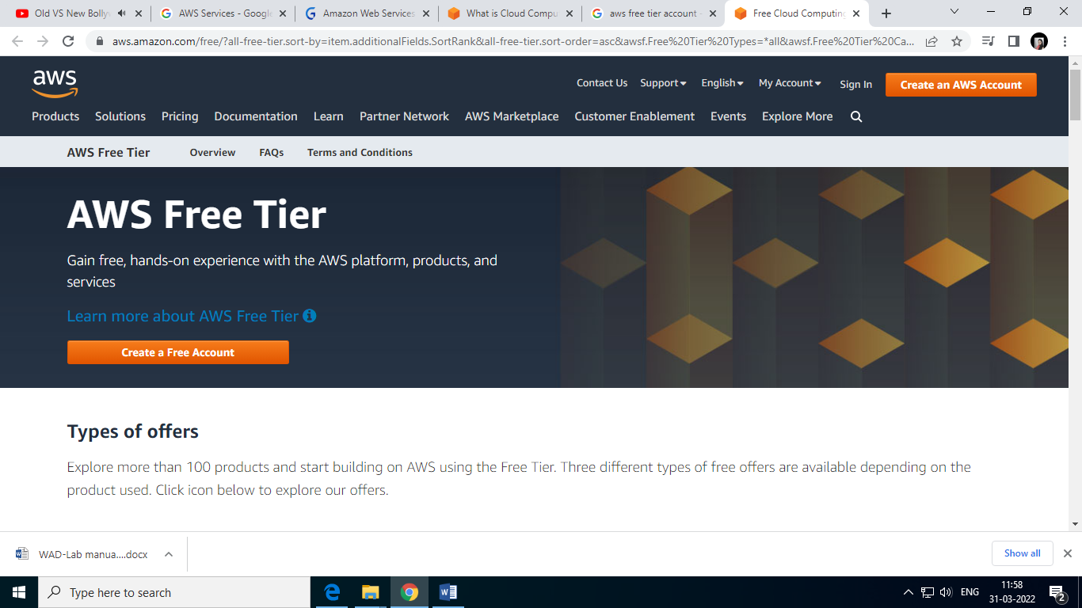

Step 2 – Entering User Details

After you have chosen to **Create a new AWS account**, you will see the below screen asking for few details.

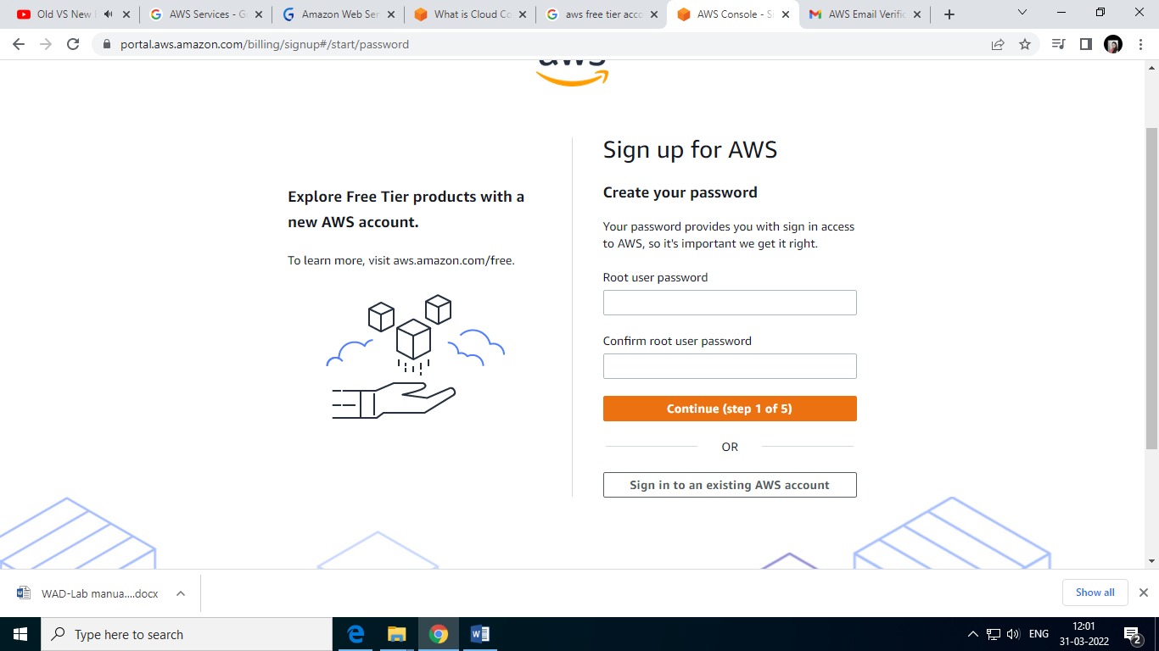

Next you will be asked to fill up your contact details such contact number, country, address and so on. You should fill them up properly because your contact number is important for further steps.

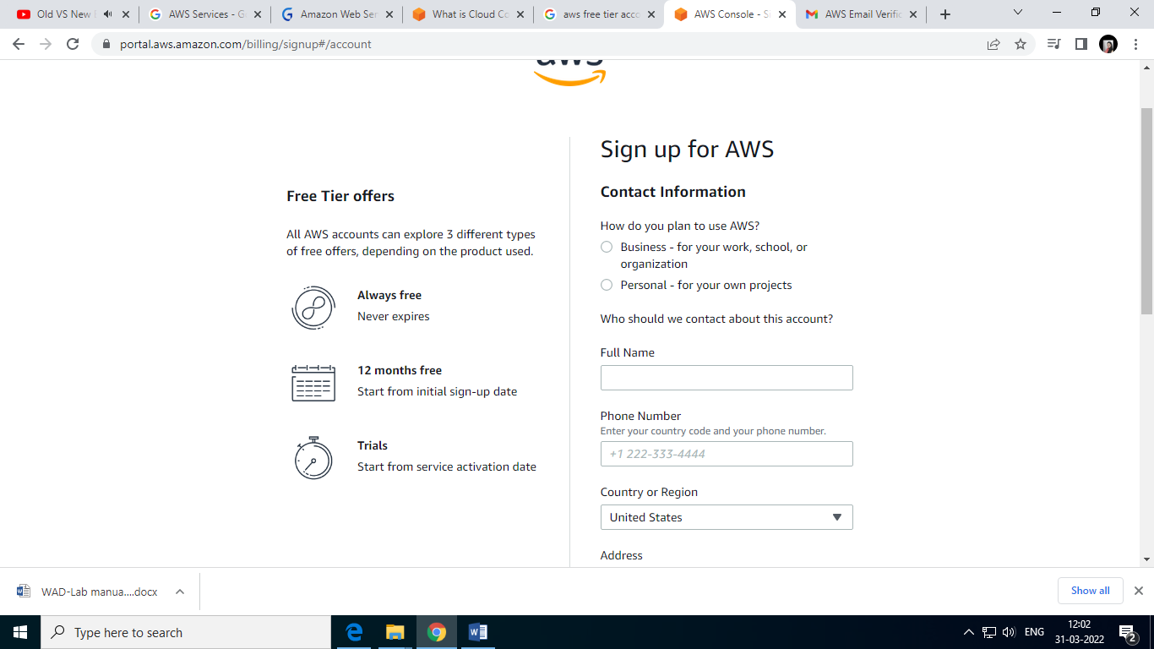

Step 3 – Filling up the Credit Card details

For **Creating an AWS Account**, you need to enter your **Credit Card** details.

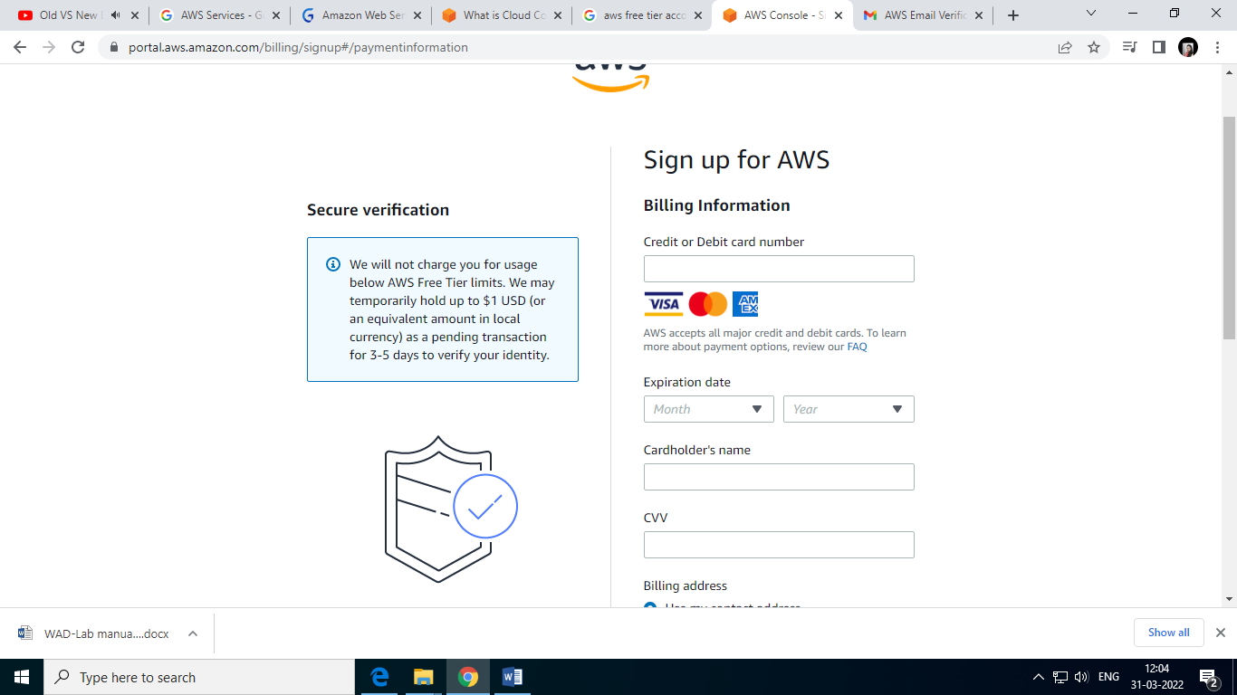

Step 4 – Identity Confirmation

Once the credit card details are confirmed, you will need to complete the **Identity Confirmation** step. You will see the below screen:

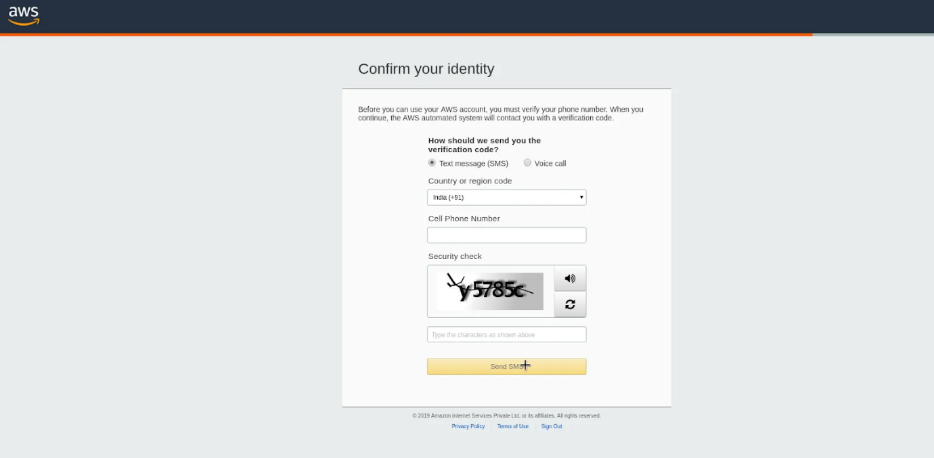

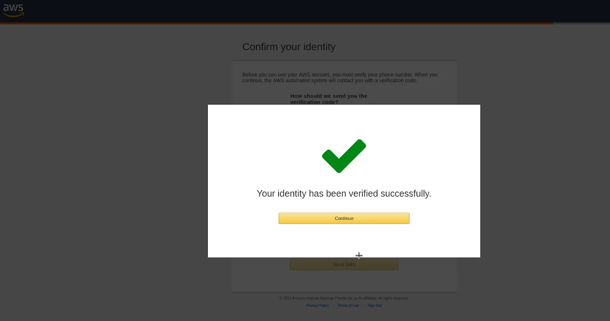

Step 5 – Selecting a Support Plan

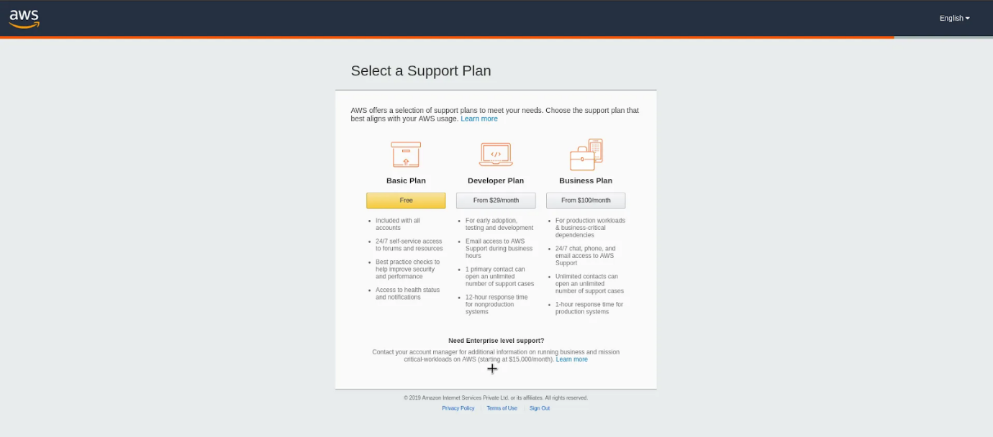

Go for **Basic Plan**. It is Free of cost and great for learning purposes.

The other plans are **Developer Plan** and a **Business Plan**. But both of them are paid options.

Once you select your plan, you will see the below **Welcome** screen. From here on, you can Sign in to your **AWS Console**.

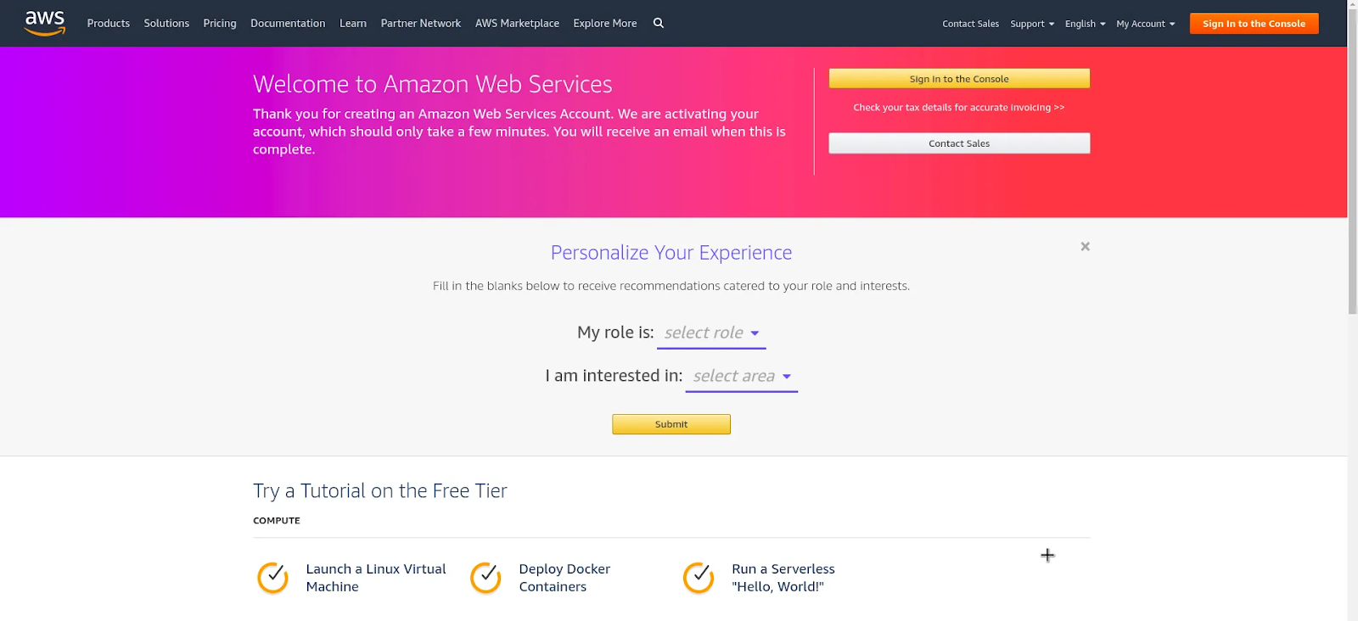

Finally, after logging in, you should be able to see the **AWS Management Console** as below:

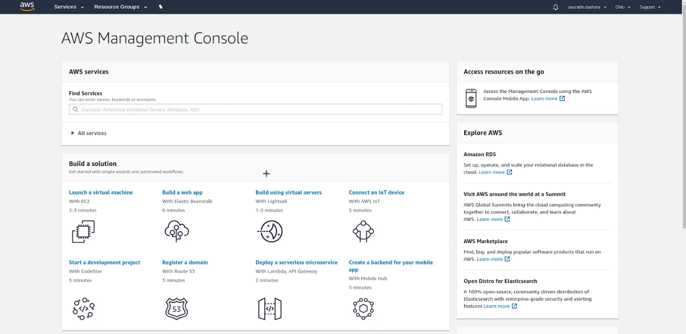

**AWS Elastic Compute**

**What Is AWS EC2?**

Amazon EC2 (Elastic Compute Cloud), one of Amazon Web Services’ most well-known services, offers businesses the ability to run applications on the public cloud.

Amazon’s Elastic Compute Cloud Web service, which provides resizable computing capacity in the cloud so developers can enjoy great scalability for building applications. To put it simply, an EC2 is a virtual machine that represents a physical server for you to deploy your applications. Instead of purchasing your own hardware and connecting it to a network, Amazon gives you nearly unlimited virtual machines to run your applications while they take care of the hardware. EC2 instances have a unique feature that is fundamental to cloud computing called Auto-Scaling Groups. This allows EC2 instances to dynamically add additional computing power as thresholds like CPU utilization are broken due to high demand. AWS supports multiple operating systems from Windows to many flavours of Linux etc. As a customer, you are also able to bring your own custom OS and run it on their platform. This allows for near limitless capabilities for running your application in the cloud.

**IN OTHER WORDS**

A custom rubber band that can stretch for building applications.

**Features of AWS EC2**

## Global Infrastructure

**Multiple Locations**

Amazon EC2 provides the ability to place instances in multiple locations. Amazon EC2 locations are composed of Regions and Availability Zones. Availability Zones are distinct locations that are engineered to be insulated from failures in other Availability Zones and provide inexpensive, low latency network connectivity to other Availability Zones in the same Region. By launching instances in separate Availability Zones, you can protect your applications from failure of a single location. Regions consist of one or more Availability Zones and are geographically dispersed. The Amazon EC2 Service Level Agreement commitment is 99.99% availability for each Amazon EC2 Region. Please refer to Regional Products and Services for more details of our product and service availability by region.

High Precision Time with Amazon Time Sync Service

The Amazon Time Sync Service provides a highly accurate, reliable and available time source to AWS services including EC2 instances. For instructions on how to access the service, see Setting the Time sections of the Linux and Windows User Guides.

**Choice of operating systems and software**

Amazon Machine Images (AMIs) are preconfigured with an ever-growing list of operating systems, including Microsoft Windows and Linux distributions such as Amazon Linux 2, Ubuntu, Red Hat Enterprise Linux, CentOS, SUSE and Debian. We work with our partners and community to provide you with the choicest possible. The AWS Marketplace features a wide selection of commercial and free software from well-known vendors, designed to run on your EC2 instances.

## Cost and Capacity Optimization

**Pay for What You Use**

With per-second billing, you only pay for what you use. It takes the cost of unused minutes and seconds in an hour off of the bill, so you can focus on improving your applications instead of maximizing usage to the hour.

**Scale Seamlessly with Amazon EC2 Auto Scaling**

Amazon EC2 Auto Scaling allows you to automatically scale your Amazon EC2 capacity up or down according to conditions you define. You can use the dynamic and predictive scaling policies within EC2 Auto Scaling to add or remove EC2 instances. Predictive scaling uses machine learning to proactively allocate instances based on anticipated demand, and dynamic scaling allows you to scale compute based on defined metrics. With EC2 Auto Scaling, you can ensure that the number of Amazon EC2 instances you’re using scales up seamlessly during demand spikes to maintain performance, and scales down automatically during demand lulls to minimize costs.

**Optimize Compute Performance and Cost with Amazon EC2 Fleet**

With a single API call, Amazon EC2 Fleet lets you provision compute capacity across EC2 instance types, Availability Zones, and purchase models to help optimize scale, performance and cost. Read FAQs and this AWS blog to learn more. You can also access EC2 Fleet capabilities via Amazon EC2 Auto Scaling to provision and automatically scale compute capacity across EC2 instance types, Availability Zones, and purchase options in a single Auto Scaling Group.

**Optimized CPU Configurations**

The Optimize CPUs feature gives you greater control of your Amazon EC2 instances on two fronts. First, you can specify a custom number of vCPUs when launching new instances to save on vCPU-based licensing costs. Second, you can disable Intel Hyper-Threading Technology (Intel HT Technology) for workloads that perform well with single-threaded CPUs, such as certain high-performance computing (HPC) applications.

**Pause and Resume Your Instances**

You can hibernate your Amazon EC2 instances backed by Amazon EBS, and resume them from this state at a later time. Applications that take a while to bootstrap and persist state into memory (RAM) can benefit from this feature.

## Storage

Optimal storage for every workload

Different Amazon EC2 workloads can have vastly different storage requirements. Beyond the built-in instance storage, we also offer Amazon Elastic Block Store (Amazon EBS) and Amazon Elastic File System (Amazon EFS) to suit other cloud storage workload requirements. Amazon EBS provides persistent, highly available, consistent, low-latency block storage volumes for use with Amazon EC2 instances, while Amazon EFS provides simple, scalable, persistent, fully managed cloud file storage for shared access.

## Networking

**High Packet-Per-Second Performance and Low Latency with Enhanced Networking**

Enhanced Networking enables you to get significantly higher packet per second (PPS) performance, lower network jitter and lower latencies. This feature uses a network virtualization stack that provides higher I/O performance and lower CPU utilization compared to traditional implementations.

**Run High Levels of Inter-Node Communications with Elastic Fabric Adapter**

Elastic Fabric Adapter (EFA) is a network interface for Amazon EC2 instances that enables customers to run applications requiring high levels of inter-instance communications, like machine learning, computational fluid dynamics, weather modeling, and reservoir simulation, at scale on AWS. EFA is available as an optional EC2 networking feature that you can enable on any supported EC2 instance at no additional cost.

**Manage Dynamic Cloud Computing Services with Elastic IP Addresses**

Elastic IP addresses are static IP addresses designed for dynamic cloud computing. An Elastic IP address is associated with your account, not with a particular instance, and you control that address until you choose to explicitly release it. Unlike traditional static IP addresses, however, Elastic IP addresses allow you to mask instance or Availability Zone failures by programmatically remapping your public IP addresses to any instance in your account. You can also optionally configure the reverse DNS record of any of your Elastic IP addresses by filling out this form.

**High Throughput and Low Latency with High Performance Computing (HPC) Clusters**

Customers with complex computational workloads such as tightly coupled parallel processes, or with applications sensitive to network performance, can achieve the same high compute and network performance provided by custom-built infrastructure while benefiting from the elasticity, flexibility and cost advantages of Amazon EC2. Cluster Compute, Cluster GPU, and High Memory Cluster instances have been specifically engineered to provide high-performance network capability and can be programmatically launched into clusters – allowing applications to get the low-latency network performance required for tightly coupled, node-to-node communication. Cluster instances also provide significantly increased throughput making them well suited for customer applications that need to perform network-intensive operations.

**Access Services Hosted on AWS Easily and Securely with AWS PrivateLink**

AWS PrivateLink is a purpose-built technology designed for customers to access Amazon services in a highly performant and highly available manner, while keeping all the network traffic within the AWS network.

## Operating Systems and Software

Amazon Machine Images (AMIs) are preconfigured with an ever-growing list of operating systems, including Microsoft Windows and Linux distributions such as Amazon Linux 2, Ubuntu, Red Hat Enterprise Linux, CentOS, SUSE and Debian. We work with our partners and community to provide you with the most choice possible. The AWS Marketplace features a wide selection of commercial and free software from well-known vendors, designed to run on your EC2 instances.

**Create EC2 Instance**

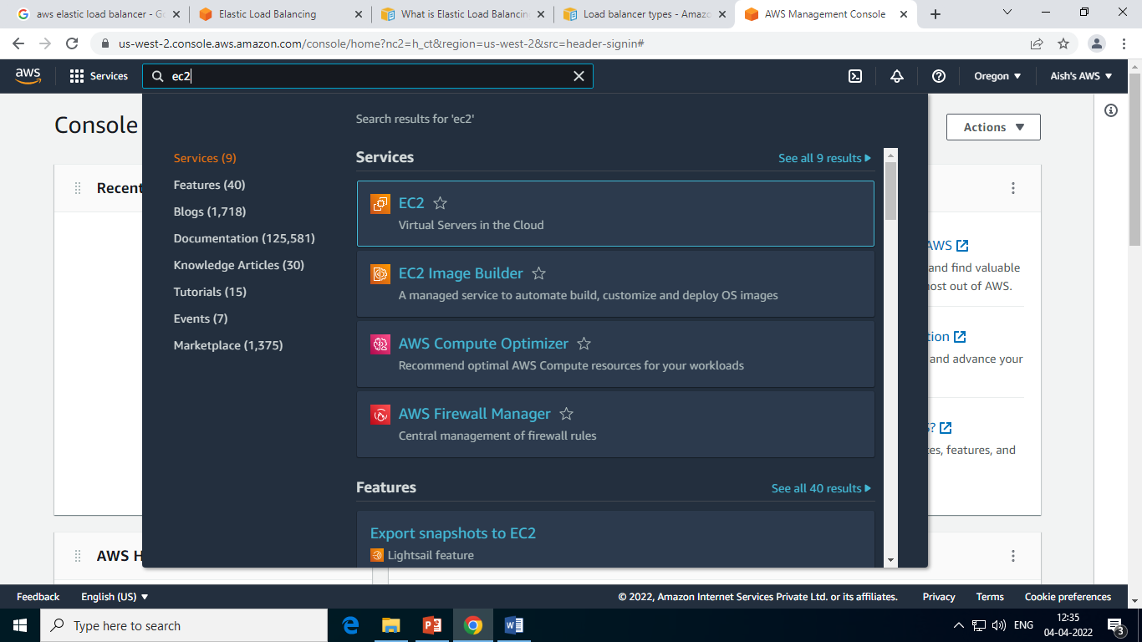

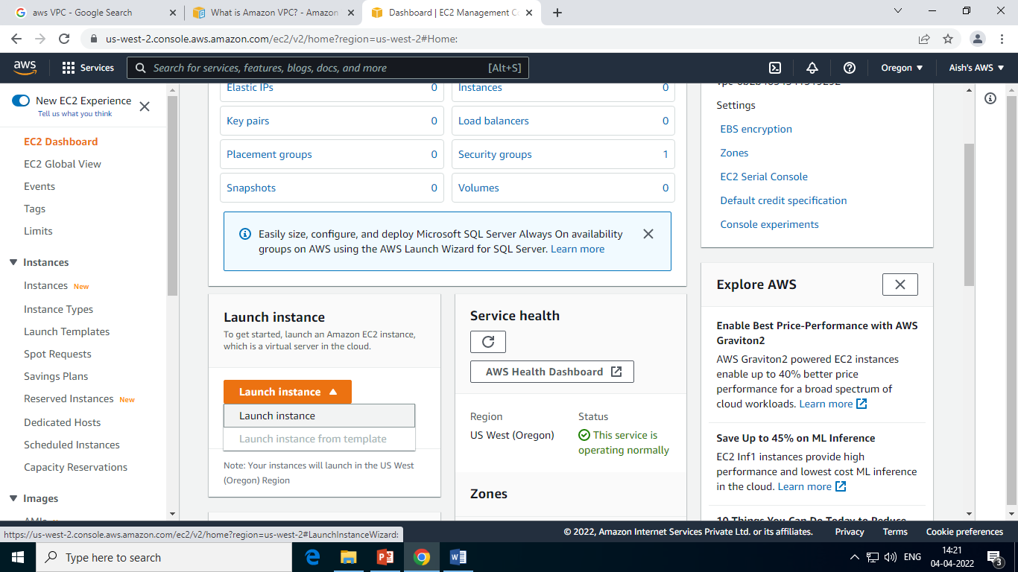

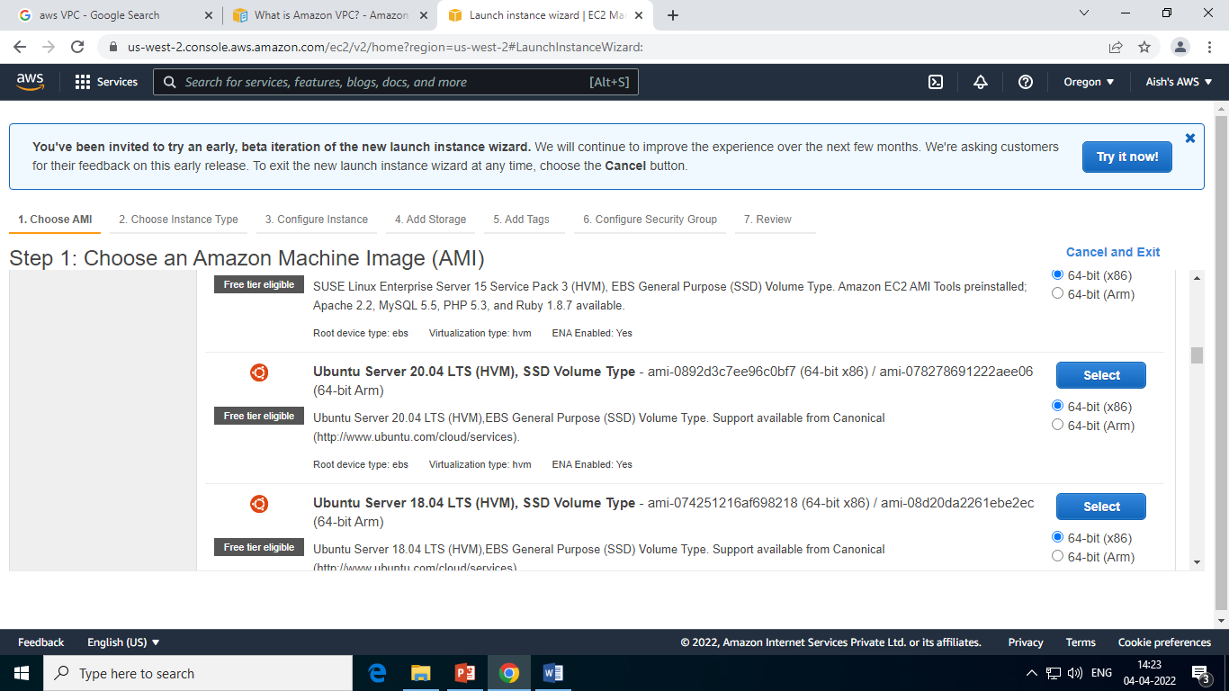

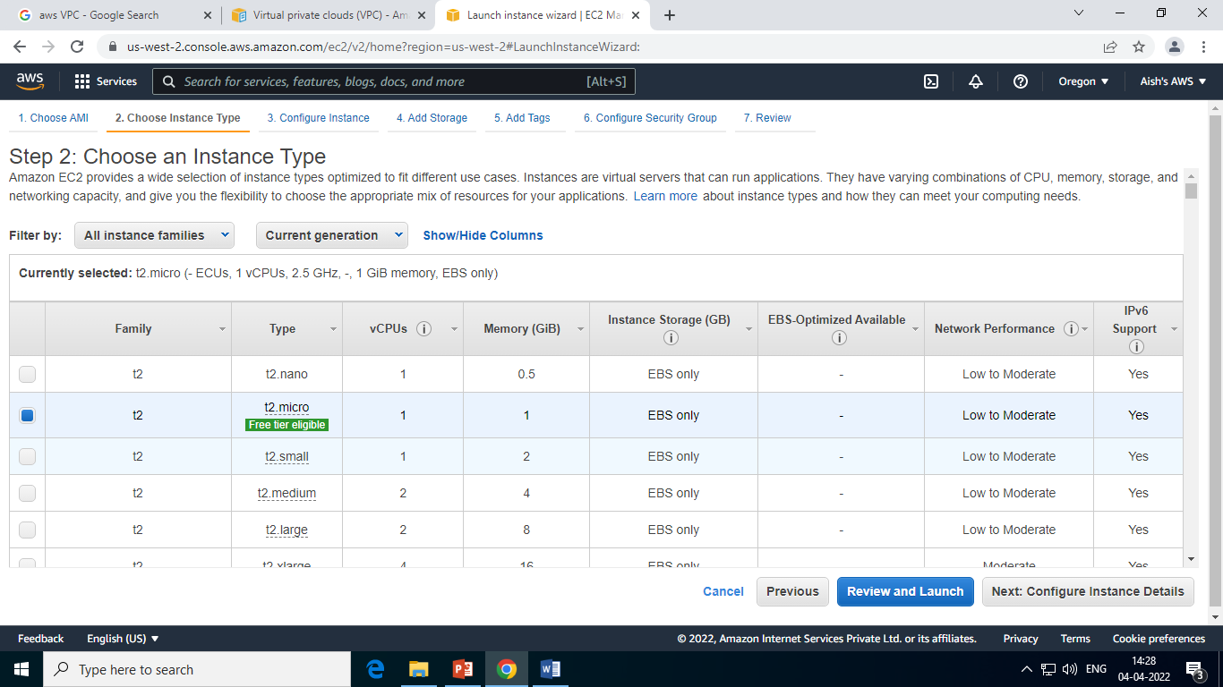

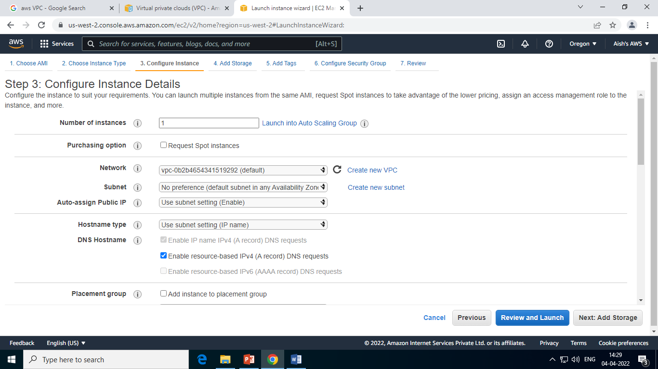

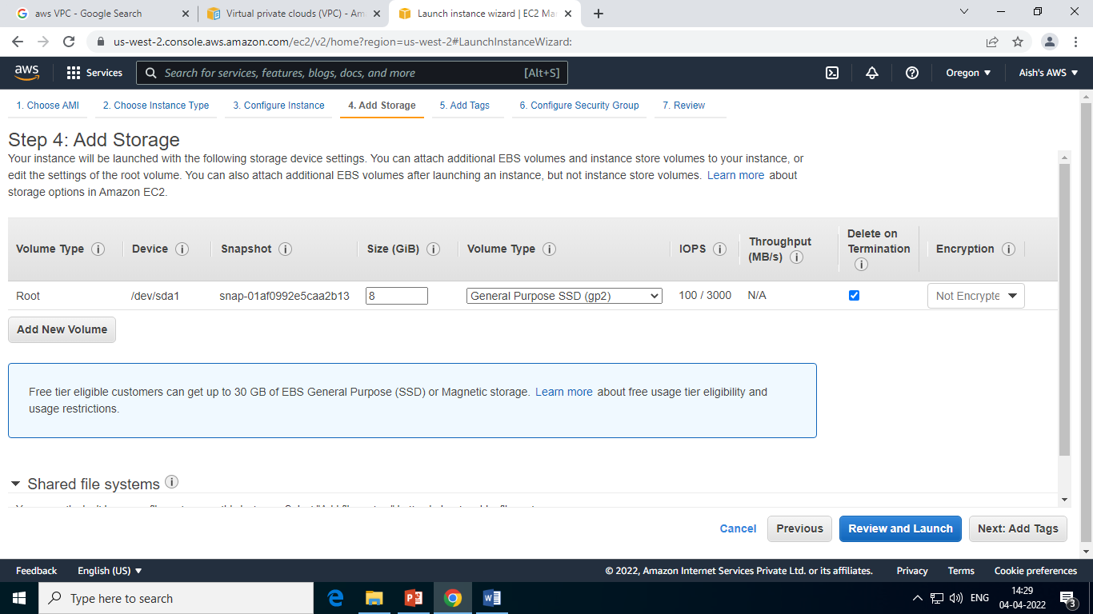

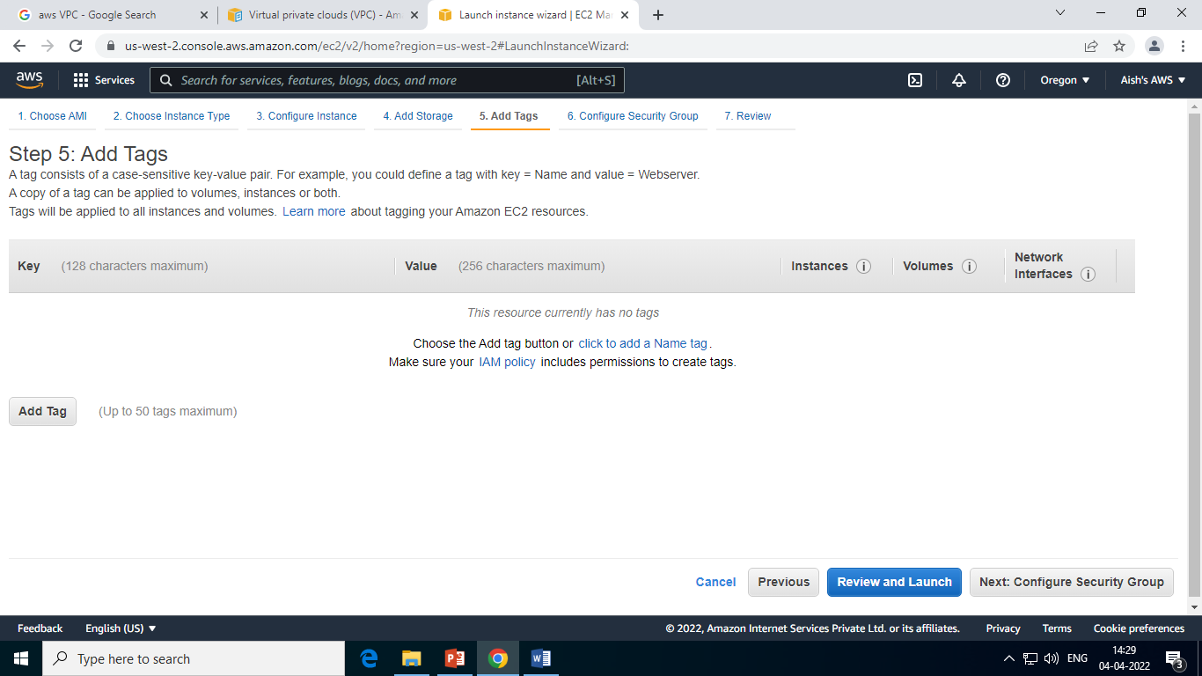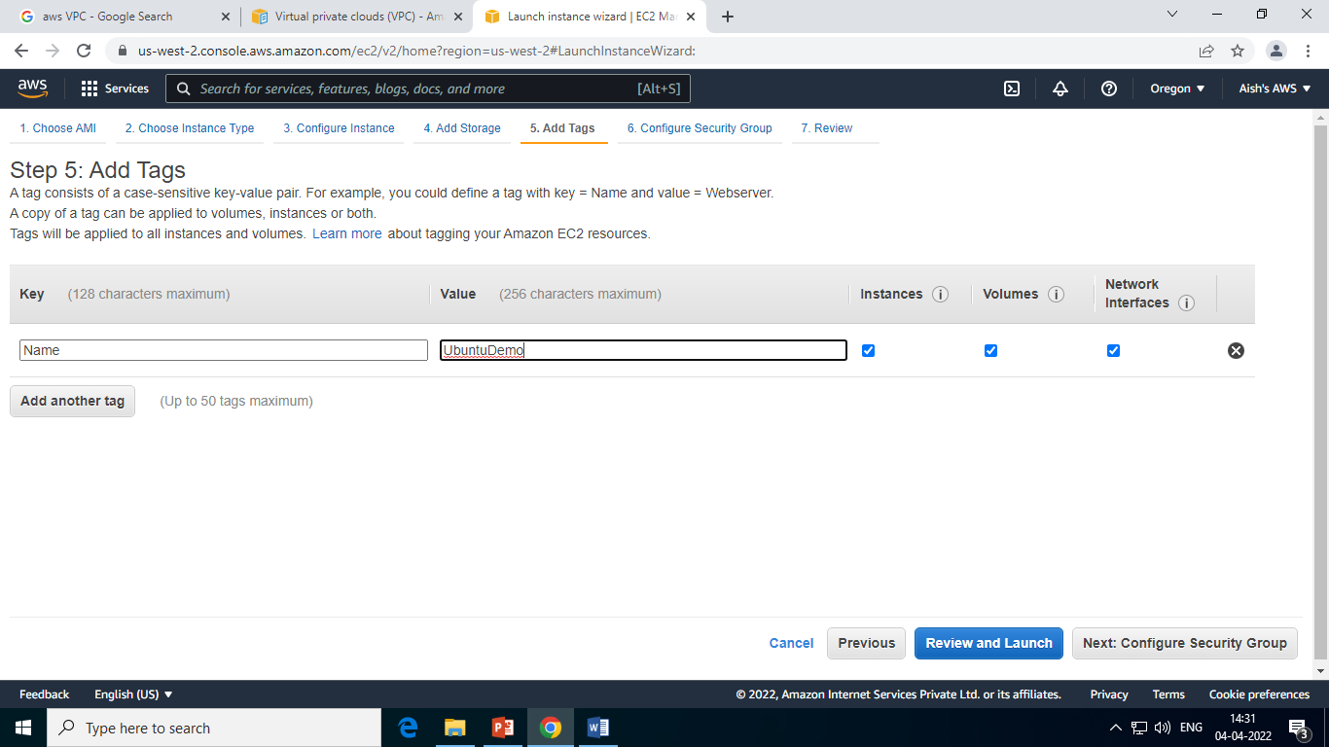

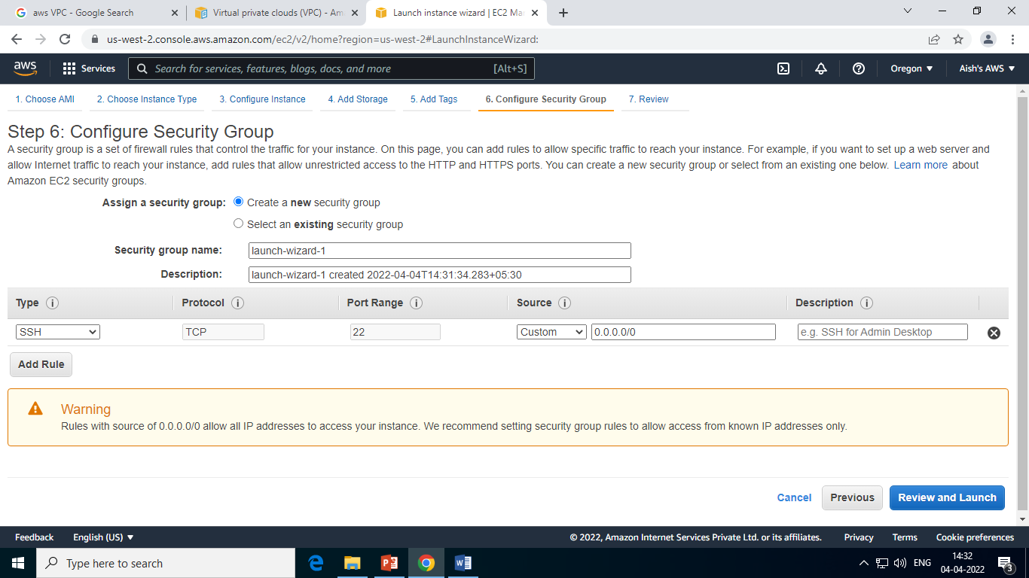

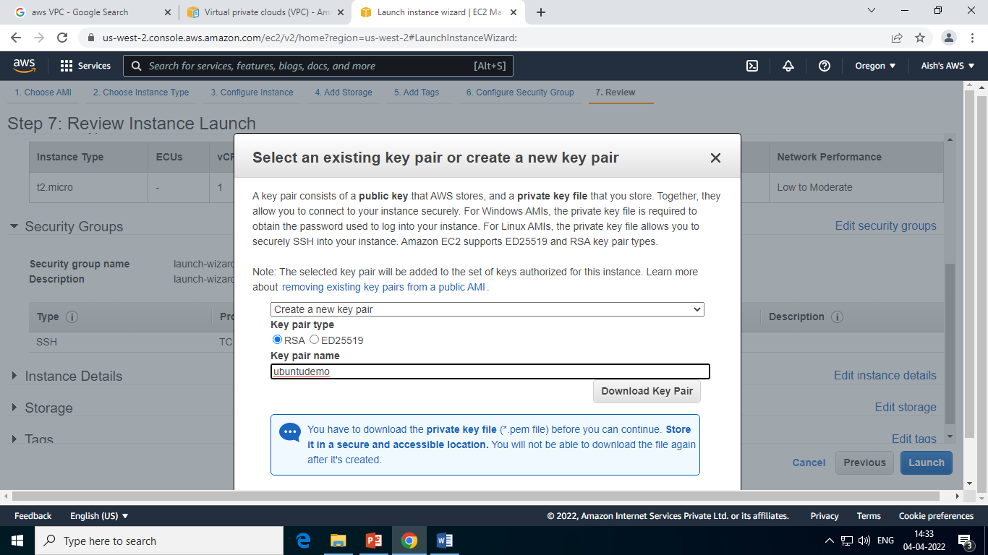

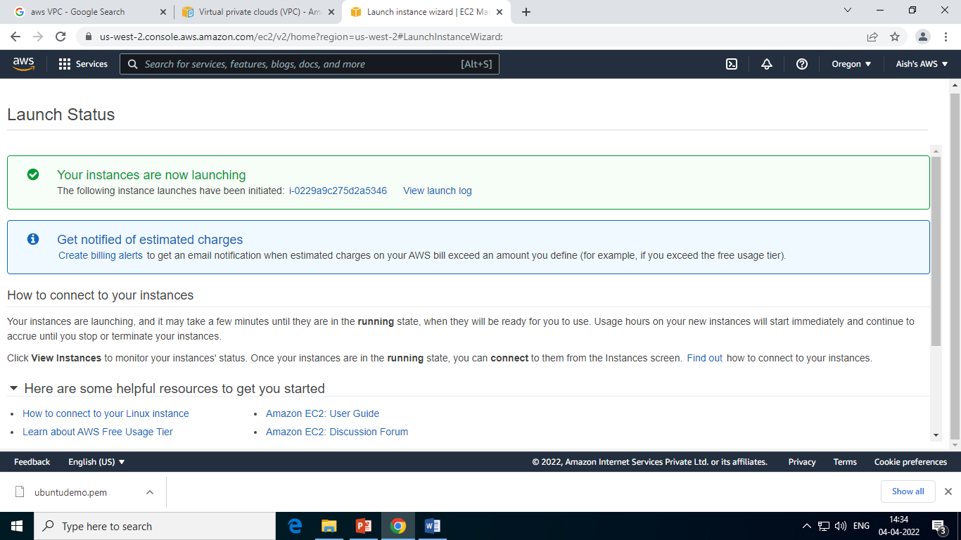

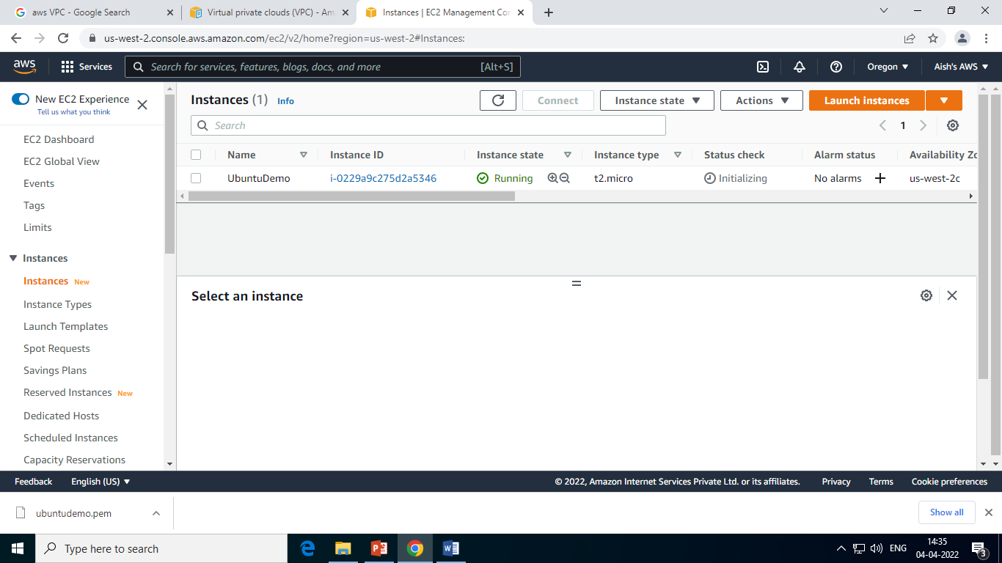

**https://www.chiark.greenend.org.uk/~sgtatham/putty/latest.html**

**AWS Elastic Load Balancer**

**What is Elastic Load Balancing?**

Elastic Load Balancing automatically distributes your incoming traffic across multiple targets, such as EC2 instances, containers, and IP addresses, in one or more Availability Zones. It monitors the health of its registered targets, and routes traffic only to the healthy targets. Elastic Load Balancing scales your load balancer as your incoming traffic changes over time. It can automatically scale to the vast majority of workloads.

**AWS Elastic Beanstalk**

AWS Elastic Beanstalk is an easy-to-use service for deploying and scaling web applications and services developed with Java, .NET, PHP, Node.js, Python, Ruby, Go, and Docker on familiar servers such as Apache, Nginx, Passenger, and IIS.

You can simply upload your code and Elastic Beanstalk automatically handles the deployment, from capacity provisioning, load balancing, auto-scaling to application health monitoring. At the same time, you retain full control over the AWS resources powering your application and can access the underlying resources at any time.

There is no additional charge for Elastic Beanstalk - you pay only for the AWS resources needed to store and run your applications.

**Benefits**

**Fast and simple to begin**

Elastic Beanstalk is the fastest and simplest way to deploy your application on AWS. You simply use the AWS Management Console, a Git repository, or an integrated development environment (IDE) such as Eclipse or Visual Studio to upload your application, and Elastic Beanstalk automatically handles the deployment details of capacity provisioning, load balancing, auto-scaling, and application health monitoring. Within minutes, your application will be ready to use without any infrastructure or resource configuration work on your part.

**Impossible to outgrow**

Elastic Beanstalk automatically scales your application up and down based on your application's specific need using easily adjustable Auto Scaling settings. For example, you can use CPU utilization metrics to trigger Auto Scaling actions. With Elastic Beanstalk, your application can handle peaks in workload or traffic while minimizing your costs.

**Developer productivity**

Elastic Beanstalk provisions and operates the infrastructure and manages the application stack (platform) for you, so you don't have to spend the time or develop the expertise. It will also keep the underlying platform running your application up-to-date with the latest patches and updates. Instead, you can focus on writing code rather than spending time managing and configuring servers, databases, load balancers, firewalls, and networks.

**Complete resource control**

You have the freedom to select the AWS resources, such as Amazon EC2 instance type and processor type to run the workload on, that are optimal for your application. You also retain full control over the AWS resources powering your application. If you decide you want to take over some (or all) of the elements of your infrastructure, you can do so seamlessly by using Elastic Beanstalk's management capabilities.

**Creating Amazon S3 Bucket**

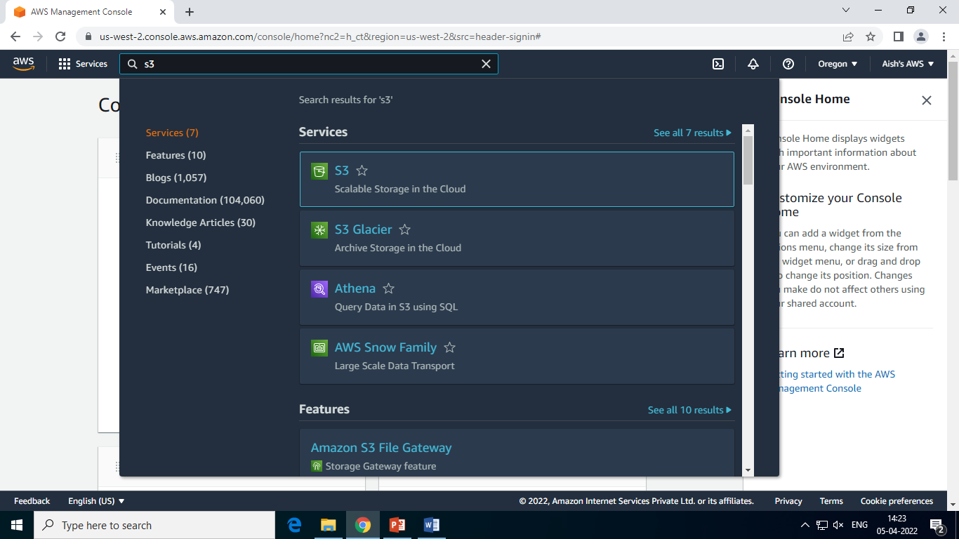

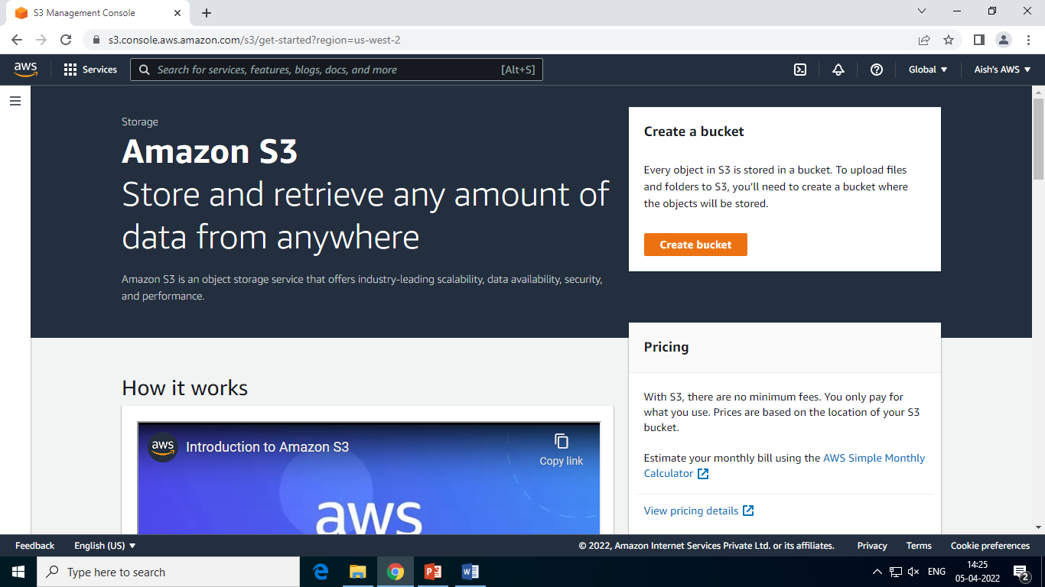

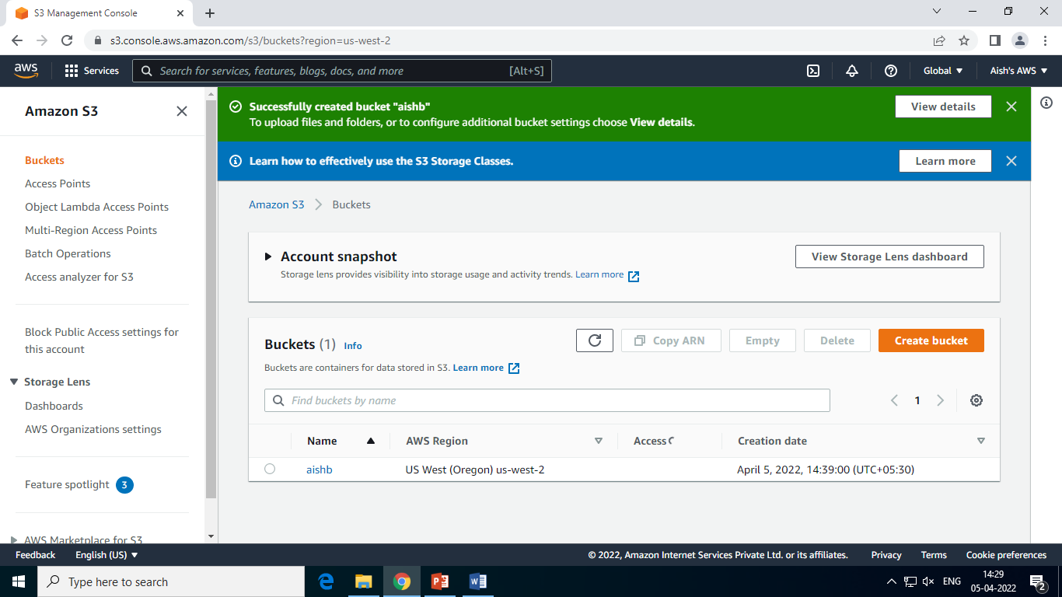

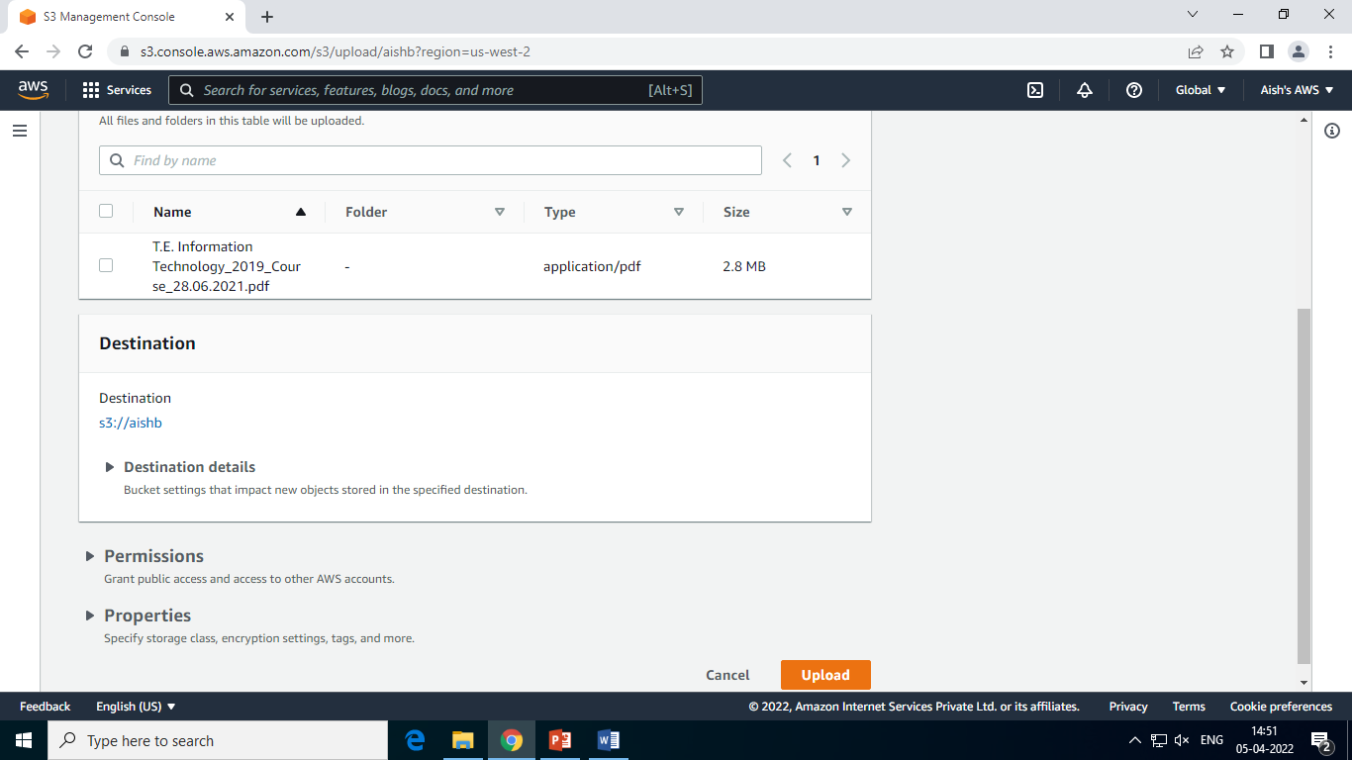

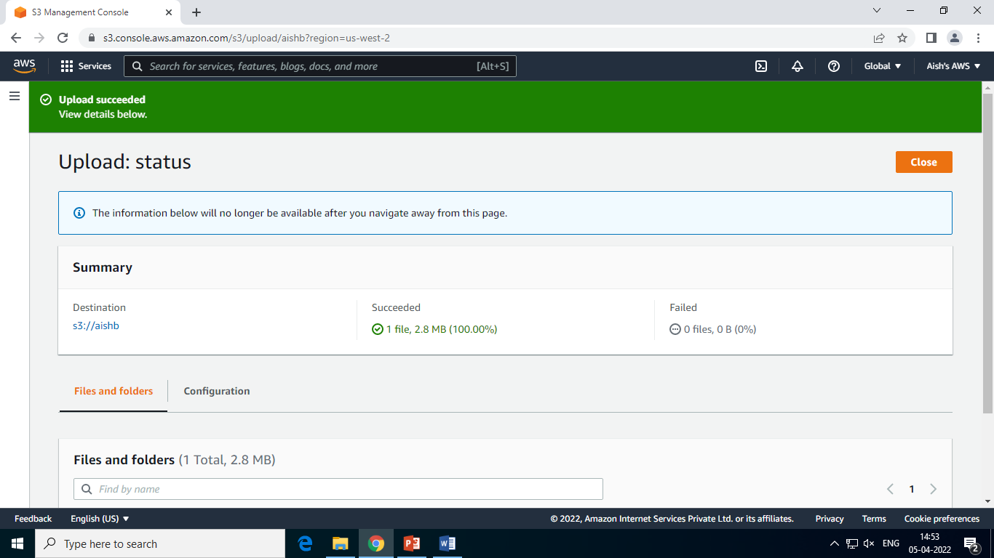

**Launch an Application AWS Elastic Beanstalk**

